HW #6 Questions

Ewan B-W

1. Phong shading interpolates the lighting parameters across the polygon and computes the lighting per fragment, while Gouraud shading computes lighting values per vertex and interpolates them over a polygon. In Gouraud shading, the color for the fragment is computed in the vertex shader and in Phong shading, the color for the fragment is computed in the fragment shader. In Phone shading you will get smooth specular highlights that don’t show any noticeable polygon edges, while in Gouraud shading you will see polygon edges around the specular light.

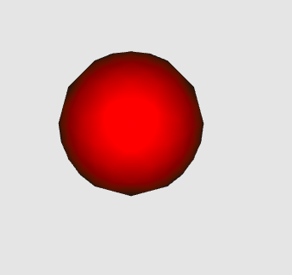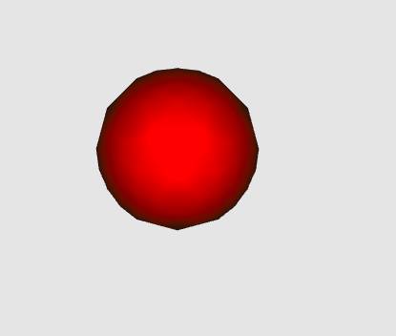

Gouraud Shading Phong Shading

2. The three components are ambient, diffuse, and specular. These components are created to make sure that the light bouncing off other objects is global.